NBA Hot Hand Theory - Milestone #3
Group: Zainab Doctor, Hai-Tsang Huang, Zecai Liang, Bailey Liao

Part 1. Project Approach and Cleaning the Data
The variables we are interested in using are Game_ID, shot_number, period or game_clock, shot_clock, shot_distance, shot_result, closest_defender_ID, close_defender_distance, FGM, points and player_ID.

We cleaned the data by eliminating shots that meet certain criteria which as a result cannot or should not be included in the analysis. Shots where the shot_clock is NaN or under 1 second and where the game_clock is under 1 second were excluded, with the assumption that these may be last-second attempts during which the ball is thrown up. The results of this filtering are shown in Figure 1.
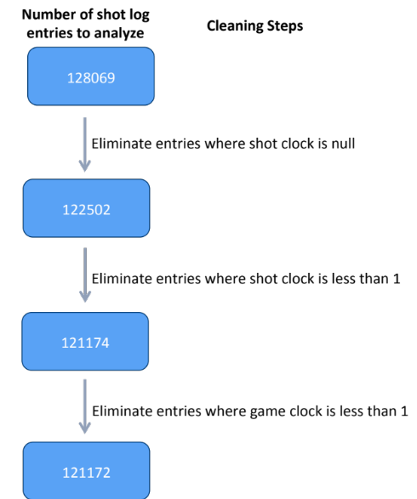
Figure 1. Result of filtering shot log data based on the criteria detailed above.

Part 2.
There are 281 players in this dataset. We looked at the distribution of how many games each player participated (Figure 2.1). Based on the median, 140 players participated in at least 54 games, so we know that we will get around 54 or more shot series for each individual player we select in the end (considering that players we are interested in participated in more games).

Next, we generated boxplots of the number of shots made per game for each player (Figure 2.2). The visualization is intuitive for representing the distribution of player’s shot numbers from game to game, and allows quick identification of players that make more shots in the games. For example, by looking at the players who made more shots per game in the first row, we identify names including Kobe Bryant, Lebron James, Carmelo Anthony, Chris Bosh, and Dwayne Wade, which aligns with our perception of who the star players are. We also looked at the number of shots made per game by all players (Figure 2.3). We think shot series with at least length of 4 is needed for the analysis of whether a player’s shot series indicates hot-hand tendency as opposed to random series. Therefore, we threw out the shot series shorter than 4. Shot series shorter than four constituted 15.9% of all shot series. After discarding those games, the median number of games played by all players dropped to around 42, but we still consider it to be a reasonable sample size (Figure 2.4).
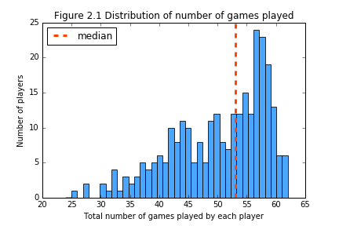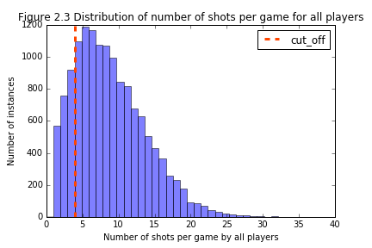
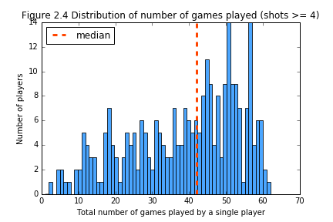
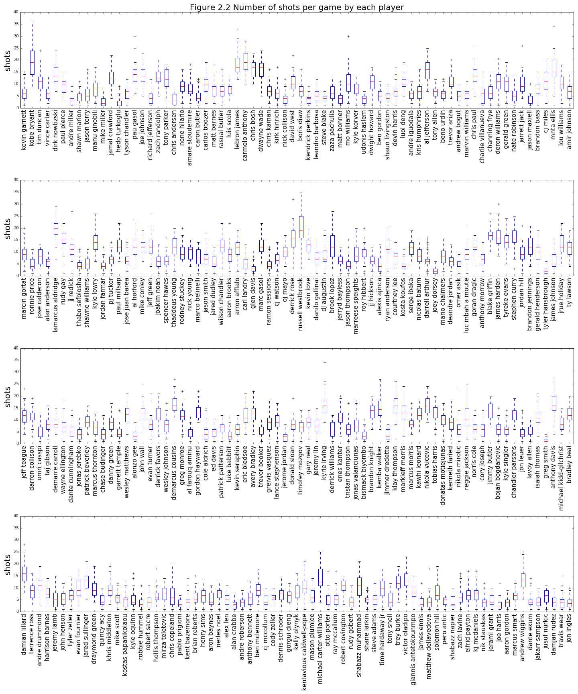

Part 3. Analysis of Top players
1. Identify of Top 5 Players with Two Criteria (PPG and FG%)
We used two criteria to evaluate players’ performance and filtered out the top 5 players:
(1) PPG (averaged points per game for each player):
Figure 3.1 shows the distribution of PPG of all the players, besides are the PPG of the top 5 players with their player_id. We can see that the distribution of PPG has a long tail on the right side.
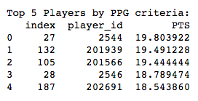
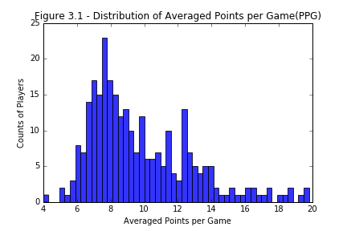
(2) FG% (= FGM / FGA *100% = field goal made / field goal attempted)
Figure 3.2 shows the distribution of FG% of all the players. We can see that the distribution is more symmetric and looks like normal distribution. The top 5 players identified by FG% are shown on the side.
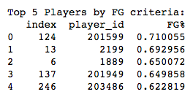
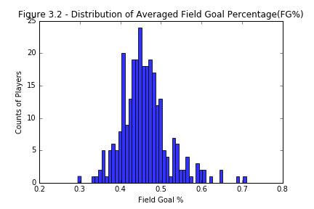
We can see that the players in the two versions of the top lists are non-overlapping. To examine how different the two top lists are, we looked up the top 5 players’ ranking in the other list. As shown in below, players who ranked high by one criteria don’t stay high under the other criteria, suggesting that the two criteria/metrics filtered out different kinds of players. We then analyzed the patterns of these two groups of top players in terms of shot distance, game played and shots made/attempted.
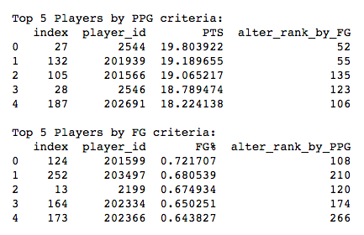

2. Different behavior patterns for the two versions of top 5 players
We first looked at the shot distance. For all the players, there are two peaks in the distribution, one is really close-distance shot (around 5 inch), the other is long-distance shot (around 25). Such pattern is consistent regardless of whether the shot is made or missed, although there are definitely more close shots among successful shots. (It is yet to be analyzed whether the long shot peaks correspond to 3-point shots.)
For top players by the PPG metrics, the distribution is quite similar.
But for the top players by the FG% metrics, the distribution is heavily shifted towards the left side, meaning they were exclusively making shots at close distance.

Figure 3.3 Distribution of Shot Distance for All Players and Top Players
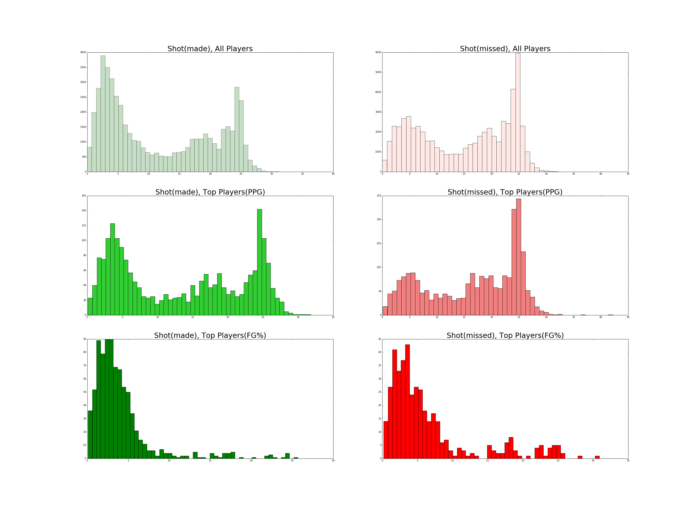

Similar analysis was done on the number of games each player has played. As can be seen in Figure 3.4, top players (PPG) played more games (above-average) while top players (FG%) played less games (below average).
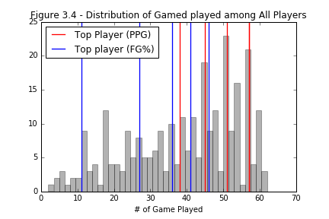

As for the FGM (field goal made) and FGA (field goal attempted), we can see in Figure 3.5 and Figure 3.6 that the top players (by PPG) attempted a lot of shots and made lots of shots; while top players (by FG%) were more restrained in attempting shots, and didn’t score as much as the top players by PPG, while they still remained top in terms of shot accuracy (FG%).
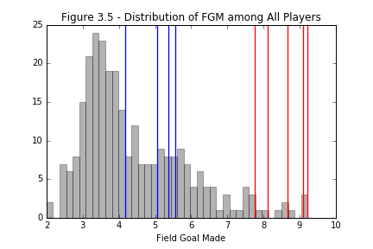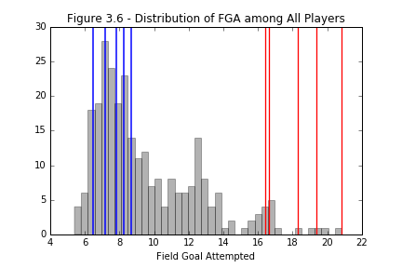
The above analysis identified two kinds of top players, and suggested their distinct behavior patterns. We would further check if the two kinds of players would show different trends in the hot hand theory.

Part 4. Make Streaks and Miss Streaks
To calculate the make streaks and miss streaks we created a new dataframe where we grouped the shots by game ID's. We did this by using the groupby function. After we grouped them we iterated through the shots within each groups and used a counter to keep track of how many shots were made and how many shots were missed in a row. If the direction changed from made to miss or miss to make we reset the counter to 0 for make streak and miss streak respectively. We then plotted a distribution to see what the average number of made shots in a row is. We do this so that in the future we should be able to compare streaks to see if a streak is abnormal and a player is extremely hot. We do the same for misses to see if a player can be on a cold streak as well.
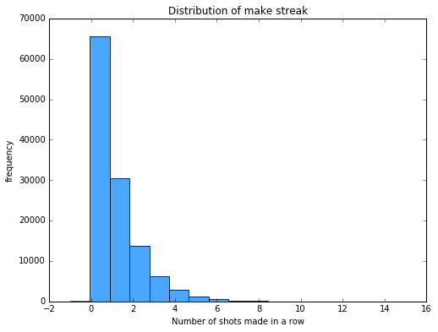
We can see that it is pretty rare for a player to even make two in a row. Most of the time a player has hit 1 in a row or has missed his previous shot. Judging from this we can analyze data with a cutoff of 3, 4 shots in a row as being 'hot'.

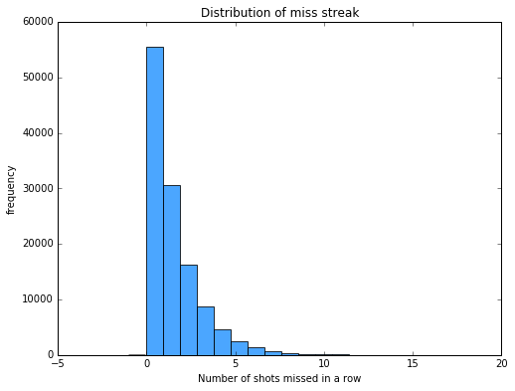
Miss distribution is similar to the make streak but has a higher right bound. This indicates that players are more likely to get cold and miss more shots in a row then make. This makes sense logically because players fg percentages are usually under 50% and thus would miss more shots in a row then they would make. So if we were to look at miss streak we would need to isolate missing more because it's a higher probability of missing or if they are missing due to being cold.

Part 5. Next Steps and Future Directions
Other features we would like to look at are whether players are more likely to get “hot” when playing at home versus away, with the hypothesis that they know their home court better. Additionally, if players are stratified based on their average points per game across a season (ie 0-10, 10-20, 20-30+ points per game), are higher tier players more likely to get hot? Are there mid-tier players that get "hot" by having nights that look like those of upper tier players? Another aspect that would be interesting to explore is using Defender_ID to investigate whether certain defenders are better at stopping or breaking streaks.

